**Dear Editor,**

**Global Change Biology**

**We are pleased with the possibility of submitting a revised version of our manuscript entitled “Coping with Collapse: Functional Robustness of Coral-Reef Fish Network to Simulated Cascade Extinction” (GCB-24-1335) by André L Luza, Mariana G Bender, Carlos EL Ferreira, Sergio R Floeter, Ronaldo B Francini-Filho, Guilherme O Longo, Hudson T Pinheiro, Juan P Quimbayo, and Vinicius A G Bastazini.**

**We found the comments and criticisms raised by the editors and the reviewers to be very instructive. Please find attached an improved version of our manuscript. Please find below a point-by-point response showing how we addressed each of the reviewers' comments (highlighted in bold).**

**We also took this opportunity to redesign our figures, and created a new schematic figure that showcases our novel analytical approach. We believe that these changes have significantly enhanced the quality of our work, and we deeply appreciate your valuable contributions.**

**We hope that the current version of our manuscript is now suitable for publication in Global Change Biology.**

**Sincerely,**

**Dr André L Luza (on behalf of the co-authors)**

Dear Dr. Luza,

The Subject Editor has determined that your manuscript, "Coping with Collapse: Functional Robustness of Coral-Reef Fish Network to Simulated Cascade Extinction”, which you recently submitted to Global Change Biology, requires major revisions. You are therefore encouraged to submit a revised version of your manuscript based on the comments of the referees and Subject Editor.

Upon resubmission, the revised manuscript will be reassessed by an Editor. At that time, your manuscript may require minor revision, be rejected without review, or be accepted. Journal policy is not to allow a second round of major revisions. If on receipt your revised manuscript is deemed by the Editors to still require major revisions, then it will be rejected.

With your revised manuscript, you must include a detailed response indicating how the manuscript has been changed in response to each of the referees’ or/and Editors’ criticisms. Upload this document with the file designation “Response to reviewer’s comments.” Also upload your manuscript file with changes tracked with the file designation “Additional file for review but NOT publication” and the clean version of your manuscript file (i.e., no highlighting or tracked changes) with the file designation “Manuscript Document.” Be sure to remove any old or redundant files.

Once the revised manuscript is ready, you can upload it and submit it through this link:

*** PLEASE NOTE: This is a two-step process. After clicking on the link, you will be directed to a webpage to confirm. ***

<https://mc.manuscriptcentral.com/gcb?URL_MASK=761df76067ef42c1b1560afb1525dfa4>

We impose a deadline of 45 days for the return of revised manuscripts. Manuscripts returned after the deadline may be regarded as new submissions, with a new receipt date, and may be subject to the full peer review process. If you need more time to prepare your revision, please contact the Editorial Office before the submission deadline.

IMPORTANT: If you upload revised files please delete the previous versions to ensure that the correct files are reviewed.

Once again, thank you for submitting your manuscript to Global Change Biology. We look forward to receiving your revision.

Sincerely,

Global Change Biology Editorial Office

Editor's Comments to the Author:

Subject Editor: 1

Comments to Author :

In agreement with both reviewers, this article presents a very interesting and novel approach to evaluate ecological changes to stress impacts. However, collectively the two Reviewers have identified a significant number of concerns that will need to be full addressed point by point. Most of these concerns appear relatively minor and not fundamental to the conclusions - and hence impact - drawn.

**We would like to thank the editors and the reviewers of Global Change Biology for their valuable criticisms and suggestions, and for giving us the opportunity of submitting a new version of our manuscript. We made our best efforts to incorporate the comments/suggestions made by the reviewers in this new version of our manuscript.**

Reviewer(s)' Comments to Author:

Reviewer: 1

Comments to the Author

This manuscript will provide an excellent addition to GCB as it presents novel results using a tripartite network of ecological connections, which is rarely used, especially in coral reef ecosystems. It's explicit test of extinction cascades is sorely needed as interactions such as this are often unaccounted for. The introduction and discussion place the work clearly in the context of existing knowledge, and the manuscript is very well written. The methods are commendably robust and thorough, and figures are very good. I only have a few comments.

1. The simulated loss of corals is from the species with the highest number of connections (to fish) to lowest number of connections. I understand that this may be due to methodological constraints - it is probably computationally demanding - but please justify why corals were not eliminated in order of their susceptibility even though you refer to this possibility in the introduction (L149-151) e.g., to bleaching, disease.... Perhaps it is to represent a worst case scenario? Or is something specific to Brazilian reefs? In the absence of a known order of susceptibility, you could have sensitivity tested the order of coral loss in the simulations to see if it does make a big difference - why was that not done? I imagine it was too computationally intensive but please tell us that if it is the case.

**R1: Thank you for the suggestion. We conceived this paper thinking in more deterministic ways to describe network robustness facing the removal of species. This is the key reason for, originally, not using other scenarios. However, based on the suggestions made by both reviewers, in this revised version, we bring results for other two scenarios: a vulnerability-based removal scenario, which is a more realistic scenario, and a random removal, which serves as a baseline to compare our deterministic scenarios. We present a short reasoning for the scenarios in the introduction (lines 183 - 202), and we added a more complete description in the methods (lines 393 - 443).**

2. The functional traits used are not justified ecologically. I imagine it is because this is what was available but it would help to explain how these traits are linked to ecosystem functions, which are brought out as the main concern in losing trait space as far as I can tell. Body size and trophic level will capture some of this (referred to at L464-467, L487-492) but I think it needs to be explained up front exactly how they are linked. There could also be recognition that other traits could be needed to capture ecosystem function, and are currently unavailable - which is fine but I think it should be mentioned.

**R2: We thank the reviewer for highlighting this shortcoming in our text regarding the absence of this information. We have now provided a more detailed ecological reasoning for selecting these traits by explaining how they influence species interactions with the environment and with other species, and how they can moderate ecosystem processes. The revised section now reads:"(lines 469-505):**

**“We used six fish ecological traits in trait space analysis: total length (cm), trophic level (the position in the food web, unitless), fin aspect ratio (unitless), group size (categories from solitary to large sized groups), maximum tolerated temperature (TºC), and depth (m). All traits, except for total body length which was obtained directly from the video estimates (Longo et al., 2019), were gathered from Quimbayo et al. (2021). These traits were chosen not only due to their availability and affordability (data set compiled by one of the authors (J.P. Quimbayo)) but also for their relevance for fish species and reef ecosystems (Hadj-Hammou et al., 2021).**

**Total length informs about the fitness variation across species, reflecting species metabolism, growth, reproduction, and mortality (Parravicini et al., 2021). Larger body sizes often correlate with higher metabolic demands and different ecological roles, impacting ecosystem-scale processes such as nutrient cycling and storage (Tavares et al., 2019). Trophic level represents the species' position in the food web and informs about species diet and ecosystem-level energy and nutrient transfer. Species at different trophic levels contribute differently to the flow of energy through the ecosystem, influencing the overall stability and functionality of the reef (Parravicini et al., 2021; Tavares et al., 2019). Group size represents gregariousness, which can influence predation rates on the benthos and other organisms. It also affects the distribution of energy within the reef through bioturbation and excretion, contributing to nutrient cycling and habitat structure (Tavares et al., 2019). Fin aspect ratio represents fish mobility and dispersion within and among reef areas. High aspect ratios typically indicate better swimming efficiency and greater mobility, which can affect the spatial distribution of species and their ability to exploit different habitats, thereby influencing gene flow and ecosystem resilience (Tavares et al., 2019). Maximum tolerated temperature and depth represent preferred habitats and position in the water column, respectively. These traits affect how energy cycles across water layers and can indicate a species' vulnerability to environmental changes such as temperature fluctuations and habitat degradation (Silva et al., 2023). They also provide insights into the vertical structure of the ecosystem and the distribution of species within the reef (Tavares et al., 2019). While these traits capture significant aspects of ecosystem function, it is acknowledged that other traits, such as metabolic rates, energy transfer, and nutrient excretion, might be needed to fully capture ecosystem functioning (Luza et al., 2023b; Tavares et al., 2019). However, as for other taxa (Luza et al., 2023b), these data are currently unavailable for most of the studied species.**

**“**

Minor comments / suggestions:

ABSTRACT

L63. change "in function to" to "as a function of"

**R3: Changed accordingly**

L66. Do you need "(ATC)"?

**R4: ATC was removed from this section**

L69/70. "showed low robustness" possibly better as "was not robust" unless statistically invalid to say that.

**R5: Changed accordingly**

L71. "projected losses" change to "projections"

**R6: Changed accordingly**

L72-73. I would split this sentence with a full stop after "area" and new sentence. Start then at "Functional...." (remove although) and change ", which", to "while much smaller, this reduction should not be overlooked". [suggestion only]

**R7: Thank you very much for the suggestion. We decided to remove this sentence from the abstract because results for other scenarios had to be added, forcing us to remove text to reach the abstract word limit.**

INTRODUCTION

L105. "reef fish establish...their habitat" --> "Reef fish are connected to their habitat to different

degrees, which can"

**R8: Thank you very much for the suggestion. We have revised this sentence accordingly.**

L125. Remove "to" after "linked"

**R9: Thank you very much for the suggestion. We have revised this sentence accordingly.**

L127. remove "with"

**R10: Thank you very much for the suggestion. We have revised this sentence accordingly. The sentence now reads (Lines 142-147):**

**“While corals are not predominantly distributed in homogeneous patches — they rather coexist with a number of taxa such as algae, sponges, ascidians (Aued et al., 2018) — they do constitute critical habitat structures adding heterogeneity and resources to reef organisms, most notably to reef fish (Anderson et al., 2022; Coker et al., 2014; Luza et al., 2022; Wilson et al., 2006).”**

L131-133. Sentence starts with a "yet" but that doesnt fit the second part of the sentence, unless you want to say "uncovered" instead of "explored"? In which case, you would need to remove "the" before "geographic".

**R11: Thank you very much for the suggestion. We have revised this sentence accordingly. The sentence now reads (Lines 147-153):**

**“The coral-fish association can be so specialized that coral mortality, cover loss and local species extinction causes direct population decline and even local extinction of coral-associated fish (Coker et al., 2014; Wilson et al., 2006). Yet, the strength of this relationship is still debated (recently reviewed by Muruga et al., 2024), and geographic variations underlying fish sensitivity to coral extinction were recently uncovered (Luza et al., 2022; Parravicini et al., 2014; Strona et al., 2021).”**

L140-142. This sentence could be more clear if you keep more consistent i.e., don't change taxonomic to species or functional loss to trait combinations. Perhaps reorder to say "Simulations suggested global loss of 50% of species and 23% of functional traits, indicating significant changes to taxonomic and functional diversity respectively."?

**R12: Thank you very much for the suggestion. We have revised this sentence accordingly. The sentence now reads (Lines 161-166):**

**“Simulations suggested global loss of 50% of fish species and 23% of functional entities with 100% coral species loss for tropical reefs, indicating significant changes to taxonomic and functional diversity, respectively (Strona et al., 2021). However, these analyses excluded Southwestern (SW) Atlantic reefs. For these reefs, the total loss of coral species caused the loss of 37% of fish species and 5% of its functional diversity (Luza et al., 2022).”**

L157-159. Is there a reference you can add for this expectation?

**R13: We added Mouillot et al. (2013, https://doi.org/10.1016/j.tree.2012.10.004) and Luza et al. (2022, https://doi.org/10.1038/s41598-022-20919-9). The first is a general reference showing how functional diversity patterns can indicate resistance to disturbances. The second is our paper about reef fish functional diversity.**

L163-165. I think this might be an overstretch considering choice of elimination order for the corals and that the functional traits are limited in scope and not clearly linked to ecosystem function.

**R14: We added other scenarios and changed according to your suggestions. Additionally, we added reasoning for the scenarios in the introduction (lines 180-196), and provided a more complete description in the methods (new topic ‘Scenario analyses’, lines 393-443). We show these changes below for your convenience:**

**Introduction**

**“Here, beyond using a tripartite network to estimate direct and indirect effects of habitat patch loss to taxonomic diversity, we take a step forward in coextinction analysis and design an algorithm that evaluates network functional robustness. We applied this approach for corals and fish of Southwestern Atlantic reefs, and considered three scenarios of coral (habitat) species loss: degree centrality, vulnerability to bleaching and post-bleaching mortality, and random removal. The degree centrality scenario reflects a deterministic mode of loss entirely based on the network structure, where the most connected species are considered more critical for the network's stability (Bastazini et al., 2019). The bleaching vulnerability scenario, where corals more susceptible to bleaching events are removed first, introduces a mechanistic influence on network robustness, considering real-world observations of coral vulnerability in Southwestern Atlantic reefs (Braz et al., 2022; Corazza et al., 2024; Pereira et al., 2022; Teixeira et al., 2019). Finally, corals were removed randomly, without imposing a specific order. Thus, the random scenario represents situations where corals might be lost due to unpredictable events or unknown factors, providing a baseline to compare against the other more realistic scenarios.”**

**Methods**

**Scenario analyses**

**We ran analyses using different criterion of coral removal in subnetwork 1 (step 1 of the algorithm). In the first scenario, coral species were removed according to their degree centrality, which was measured as the number of links between each coral and fish species. In this scenario, coral removal followed a decreasing order, from the highest to the lowest degree centrality. Therefore, coral with the largest number of associated fishes were the first to be eliminated.**

**The second scenario involved the random removal of coral species in step 1, where we shuffled the rows in partite A one thousand times. Then, we ran the algorithm steps 2-7 as described above for each random data set. At the end of the randomization we obtained the average robustness R ̅ and associated 95% Confidence Intervals.**

**The third scenario involved the removal of corals based on their vulnerability to bleaching and post-bleaching mortality. The key drivers of coral mortality and eventual loss are their vulnerability to bleaching and ability to recover from bleaching events (Bleuel et al., 2021; Freeman et al., 2013; Hoegh-Guldberg et al., 2007). Nonetheless, bleaching vulnerability and post-bleaching mortality vary with biological species traits such as occurrence depth, symbiotic association, growth rate and competitive ability (to endure against competition with algae and zoanthids). Using this background information we went to the literature to gather data to build a vulnerability-based scenario, in which corals with higher bleaching probability and post-bleaching mortality and lower growth rates and competitive ability were removed first from the network. The vulnerability-based scenario respected the following order:**

**1- Mussismilia harttii - high bleaching levels, high post-bleaching mortality levels (see Corazza et al., 2024; Pereira et al., 2022; Teixeira et al., 2019), low recovery rates leading to colony erosion (Braz et al., 2022);**

**2- Millepora alcicornis - high bleaching levels, high post-bleaching mortality levels (see Corazza et al., 2024; Pereira et al., 2022; Teixeira et al., 2019). The species has high competitive ability and growth rates, often considered a weedy species in the Caribbean (Cramer et al., 2021), therefore with a higher recovery potential compared to M. harttii;**

**3- Agaricia spp. - high bleaching levels and post-bleaching mortality (Corazza et al., 2024; Pereira et al., 2022; Teixeira et al., 2019), and low recovery potential (Longo unpublished data; Cramer et al., 2021).**

**4 - Mussismilia hispida - high bleaching levels, low post bleaching mortality (Banha et al., 2020), slow growth and recovery rates (Corazza et al., 2024);**

**5 - Montastraea cavernosa - medium bleaching levels and low post bleaching mortality (Teixeira et al., 2019), considered a stress tolerant species (Cramer et al., 2021). This species is very important for the benthic community structure in turbid and deeper reefs in SW Atlantic (Santana et al., 2023).**

**6 - Porites astreoides - medium bleaching levels and low post bleaching mortality, considered a weedy coral in the Caribbean with a high reproductive output (Cramer et al., 2021).**

**7 - Favia gravida - high bleaching levels and post-bleaching mortality (Corazza et al., 2024; Pereira et al., 2022; Teixeira et al., 2019). The species is a monthly spawner with good recovery potential (Longo unpublished data; Pereira et al., 2020).**

**8 - Siderastrea sp., - high bleaching levels but extremely low post-bleaching mortality (Mello et al., 2023), considered a stress tolerant species (Cramer et al., 2021).**

METHODS

L174. change "in function to" to "as a function of"

**R15: Changed accordingly.**

L191-2. Remove "a" before species and site

**R16: Changed accordingly.**

L248. Probably my mathematical ignorance (sorry!) but just checking if "(t < | A)" should have a

zero after the "<"?

**R17: In this new version we provide more details about the algorithm, which might clarify this question.**

**The algorithm’s description now reads (lines 315-372):**

**“We simulated species extinctions in the network and evaluated direct and indirect effects using the following algorithm:**

1. **Let be a bipartite network (subnetwork) with two sets of nodes each:**
   1. **Subnetwork 1: corals () and coral-associated fish ()**
   2. **Subnetwork 2: Coral-associated fish and co-occurring fish ()**

**The links between and were defined by , and the Pearson's correlation coefficient *⍴* was used to connect and (Fig. 2).**

1. **Let be the function to estimate taxonomic and functional diversity for species in the set given losses . Let be the function to estimate taxonomic and functional diversity for species in given losses in the set .**
2. **Reduction in taxonomic diversity (TD) is the proportion of fish species being lost in and along eliminations of corals in .**
3. **The Reduction in Functional Space (RFS) of partites and is then calculated using traits and node identities (see below Trait space area and occupancy):**

**Time is defined in terms of coral removal order, where represents the baseline time step with no coral removal. depicts the number of corals in the partite .**

**From onwards, the algorithm will run while . In other words, the algorithm will run while there are nodes remaining in the subnetwork as follows:**

1. **Select a species in based on one specific criterion (see Scenario analyses), and remove it from the network at time ;**
2. **Update the network by removing the links associated with species :**
3. **Estimate the taxonomic and functional diversity for species in the partites and ( and , respectively);**
4. **Add the values of and to the cumulative sum of the area under the attack curve (ATC):**

**or**

1. **Increment the time step until . The algorithm then ends when all coral species from subnetwork 1 have been removed from the network.**

**To analyze the decay of taxonomic and functional robustness with coral loss, we fitted a hyperbolic function to data obtained across the time steps. This step involves attempting to fit a non-linear least squares’ model of the form to the data, represented as . The variable depicts the time (from to ), and the exponent is the decay function to be estimated by the model. If the fitting fails, we added a small amount of random noise () to to enable the fitting process to converge, and set as the starting value of the maximum likelihood algorithm.**

**Finally, robustness was quantified for taxonomic and functional diversity of node sets and separately by integrating (summing up) infinitesimally small values of the spline interpolation of the fitted hyperbolic function applied over the interval (, no coral removed) to (, all corals removed):**

“

L250. Add on the end "from highest to lowest degree centrality"

**R18: Changed accordingly.**

L257. Is this right "t <- t+1."?

**R19: Changed accordingly. See R17.**

RESULTS

Figure.1. Acropora are mentioned in the introduction but none are included in the analysis...

**R20: We don’t have *Acropora* in SW Atlantic reefs. It was just a general example.**

Figure 3 circles vs squares are not very clear - could you choose a different shape or not fill some of them to make it more obvious?

**R21: Changed accordingly. The figure now looks like:**

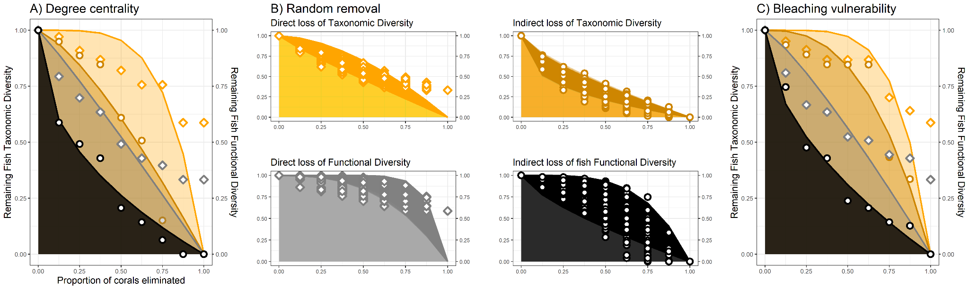

***Fig. 4 - Attack Tolerance Curves (ATC) depicting direct and indirect effects of coral loss on fish taxonomic and functional diversity along three scenarios of coral removal: A) degree centrality, B) random, C) bleaching vulnerability. The shaded area below each curve depicts the hyperbolic function curve fitted to the data shown in the two Y-axes. Direct effects comprise the loss of fish taxonomic and functional diversity caused by coral loss. Indirect effects comprise extinctions of fish whose number of occupied sites was correlated with the number of sites occupied by coral-associated fish. The colors and points shown in B (random scenario) aid to differentiate effects in scenarios based on degree centrality (A) and bleaching vulnerability (C).***

DISCUSSION

L408. Consider changing "take time to happen" to "unfold over long time scales"

**R22: Changed accordingly.**

L414. Not sure you can say they are applied given the method to choose order of coral loss. Isn't it instead a worst case scenario?

**R23: We adjusted the section, and mentioned that the degree centrality scenario resulted in less robustness than the vulnerability-based scenario. The sentence now reads (lines 649-669):  
  
“Coextinctions are difficult to observe in nature as they are hard to detect or unfold over long time scales (Estes et al. 2011). Using simulated cascade extinctions in a tripartite species-habitat network, we showed that cascading loss of reef fish species and functions can occur as a response to coral species loss in Southwestern Atlantic reefs. There was a limited robustness of the network and ecological trait space to the direct and indirect influence of the removal of corals with high degree centrality. By evaluating network robustness across the gradient of coral species loss, our analyses of co-extinctions can represent a more realistic and applied scenario in terms of conservation than our previous results (Luza et al., 2022) based on a more conservative scenario of direct extinction of coral-associated fishes. Notably, fish TD and FD was more robust to the removal of the corals most vulnerable to bleaching, showing a weak relationship between coral bleaching vulnerability and fish assemblage vulnerability. The removal of corals with more associated fish (highest degree centrality*, Millepora alcicornis*, *Mussismilia hispida*) caused the largest direct and indirect impacts on the network's robustness. It was already shown for a seed dispersal network that species with a high degree centrality confer network robustness and stability (Bastazini et al., 2019). Such results are particularly useful for informing management and conservation actions, informing the key corals and fish to target conservation considering the major coral loss scenarios projected over the next 76 years (Bleuel et al., 2021; Freeman et al., 2013; Hoegh-Guldberg et al., 2007).”**

L427. change "fact" to "exclusion"?

**R24: Changed accordingly.**

L435-440. Again, I'm not convinced by this line of reasoning unless the traits are fully explained. Which functions are being maintained? Which are lost? Which traits are allowing you to draw those conclusions? For example, which function on the reef is delivered according to the temperature tolerance of species?

**R25: We provide justification for the traits we used, and hope you find this context sufficient to support this line of reasoning.**

Reviewer: 2

Comments to the Author

I have reviewed the manuscript entitled ‘Coping with Collapse: Functional Robustness of CoralReef Fish Network to Simulated Cascade Extinction’. The topic is timely and relevant, and I particularly enjoyed the analytical approached used in this study. Generally, the study contributes to understand the impacts of human disturbance on coral reefs and associated ichthyofauna, unveiling the taxonomic and functional resilience of the assemblages following coral cover removal. Overall, the text is generally well-written—despite it would still benefit from some re-writing (see my comments below)—and the analytical approach seems to be appropriate and well applied. Yet, I have some criticism mostly on the assumptions on which the analysis is build. My major concerns follow below. Moreover, in the introduction, I missed some information regarding those functions, e.g., which functions will be lost in first place, and why would that be. The methodology would greatly benefit from a diagram illustrating the several steps used. The result section is quite long and including some interpretation that must be moved to the discussion. The discussion would benefit from sub-titles and by stating quantitative values that can be derived from the results (e.g., for which amount of coral loss is observed a loss in 50% of the associated fishes, and for which amount of coral loss is observed the same but in terms of functionality provided by fishes).

**R26: Dear reviewer. Thank you very much for the comments and questions raised. We make an effort to answer and solve all them. We would like to mention here that we added on the main text (Figure 1) a simple diagram illustrating the framework we adopted (shown below with the caption for your convenience).**

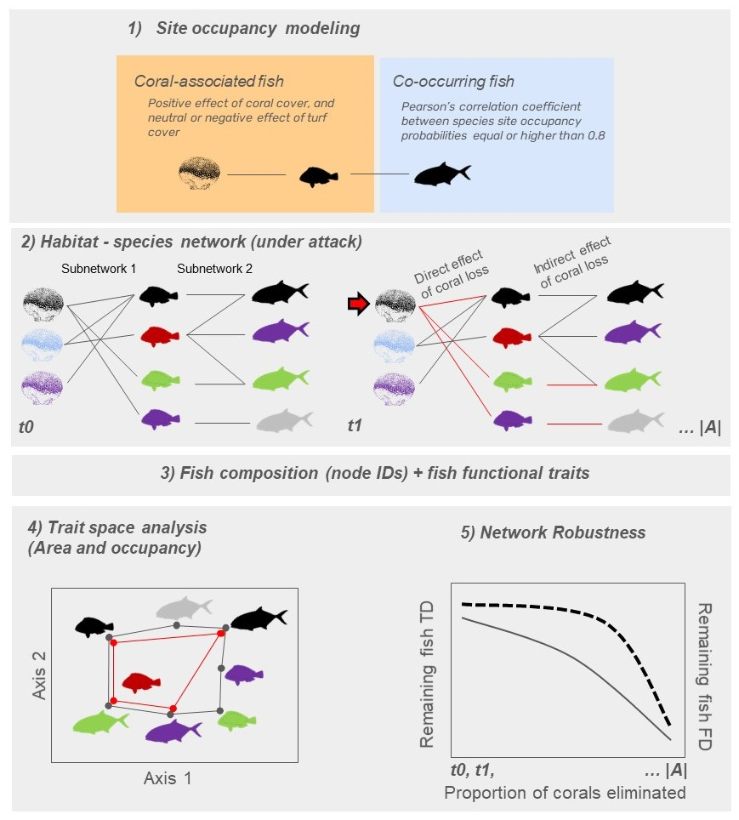

***Fig. 1: Framework used in the study. The first step (1) involved relating fish site occupancy probability with coral and turf algae cover using site occupancy modeling. Using the model output we classified species in coral-associated and co-occurring fish. The second step (2) comprised connecting corals and fish. The connection between corals and coral-associated fish in subnetwork 1 was established using the predicted site occupancy probability of each coral-associated fish (fish with different colors in the center of the network) relative to the cover of each coral species (corals with different colors in the left of the network). The connection between coral-associated and co-occurring fish in the subnetwork 2 was established based on the Pearson’s correlation between fish site occupancy probability. With the network already built, we ran the removal algorithm that eliminated corals, and subsequently computed the direct and indirect effects of coral species removal to the network robustness at each elimination step (t0, t1, to |A|). Lost links are shown in red. The third step (3) involved connecting fish species composition and species traits at each elimination step. The fourth step (4) consisted in computing the loss of trait space area along the elimination of corals and fish. The area delimited by the black polygon depicts the trait space area at t0, and the area delimited by the red polygon depicts the trait space area at t1. The fifth step (5) involved fitting a hyperbolic function (non-linear model) to robustness data regarding the remaining taxonomic (TD, first y-axis, solid curve) and functional diversity (FD, second y-axis, dashed curve) along the gradient of coral elimination (x-axis).***

1 – The use of ‘multilayer’ approach diverges from that proposed by Pilosof et al. (2017), which is especially useful to quantify model ‘intralayer’ and ‘interlayer’ connectivity. In this study, network metrics are calculated between two pairs of partite, which makes me think this is rather a tripartite network rather than a multi-layer network (also the nature of the links differ between partite A-B and partite B-C, see my comment below on that).

Pilosof, S., Porter, M. A., Pascual, M., & Kéfi, S. (2017). The multilayer nature of ecological networks. Nature Ecology & Evolution, 1(4), 0101.

**R27: Thank you for this comment about this important concept in our manuscript. We agree with this point and have now replaced “multilayer” by “tripartite” throughout the text.**

2 – In multiple instances authors mention ‘the direct and indirect effects of coral loss to reef fish communities’ but it is not disclosed before line 282 what do the authors mean by such direct and indirect effects. Introduction should cover this aspect with background information and hypothesis/expectations on that. Also on this regard, while I understand that co-occurring fish do not have a relationship with corals (partite A), it is not clear to me why would those have a stronger relationship with the coral-associated fish species (partite B). In other words, how likely is that extinction of coral-associated fishes would cause an extinction in the ‘co-occurring’ fishes?

**R28: We used the ANOVA to detect whether the trophic level was higher among co-occurring fish than coral-associated fish -- and it was indeed the case. As far as we could see from this, these two sets of fish species are linked by trophic relationships (which is interesting and somehow surprising since we used correlation as a proxy for co-occurrence). Additionally, we tried to inform about direct and indirect effects earlier (Lines 116 - 120):  
   
“Reef fish are connected to their habitat to different degrees, which can include the use of reef corals and macroalgae for sheltering, breeding, and foraging (Sheppard et al., 2018). Other fish can in turn associate or co-occur with coral-associated fish due to predator-prey relationships (Capitani et al., 2022), facilitation cascades, habitat engineering, and mutualistic interactions (Quimbayo et al., 2018).”**

3 – Another aspect that was not considered was the spatial distribution of surveyed coral patches (a map on the study area would be highly appreciated). Coral isolation from other corals can affect the occupancy probability of coral-associated species. Indeed, if a coral patch, even if small, is close to another coral, then it would positively affect the occupancy probability. Information on whether this aspect has been accounted for should be added or, if not, how would that limit/cause any bias in the reported results.

**R29: We appreciate the reviewer’s insight about this topic. The main intent of the benthic sampling plan was to characterize different reef sites across a continental scale (Aued et al. 2018, 10.1371/journal.pone.0198452). Although spatial data on the exact size or isolation of sampled reefs were not estimated, all sampled reefs are considered large and well-connected reef environments. No isolated and small patch reef was sampled. Thus, we believe that each sample for each site has the same chance to capture the full spectrum of cooccurrence and network provided by the local species pool and the influence of benthic characteristics.**

**To address this comment, we have incorporated a map of the study area in the Online Supporting Information to provide a visual representation of the surveyed locations (shown with the caption below). Additionally, we have added a short sentence on this matter in lines 235-242.**

**Sentences about coral isolation:**

**“One relevant aspect not considered in this model is the spatial configuration of coral or turf patches and their effects on fish occupancy. Although spatial data on the exact size or isolation of sampled reefs were not estimated, all sampled reefs are considered large and well-connected reef environments. Accordingly, we assumed that each sample for each site had the same chance to capture the full spectrum of cooccurrence and network provided by the local species pool and the influence of benthic characteristics.”**

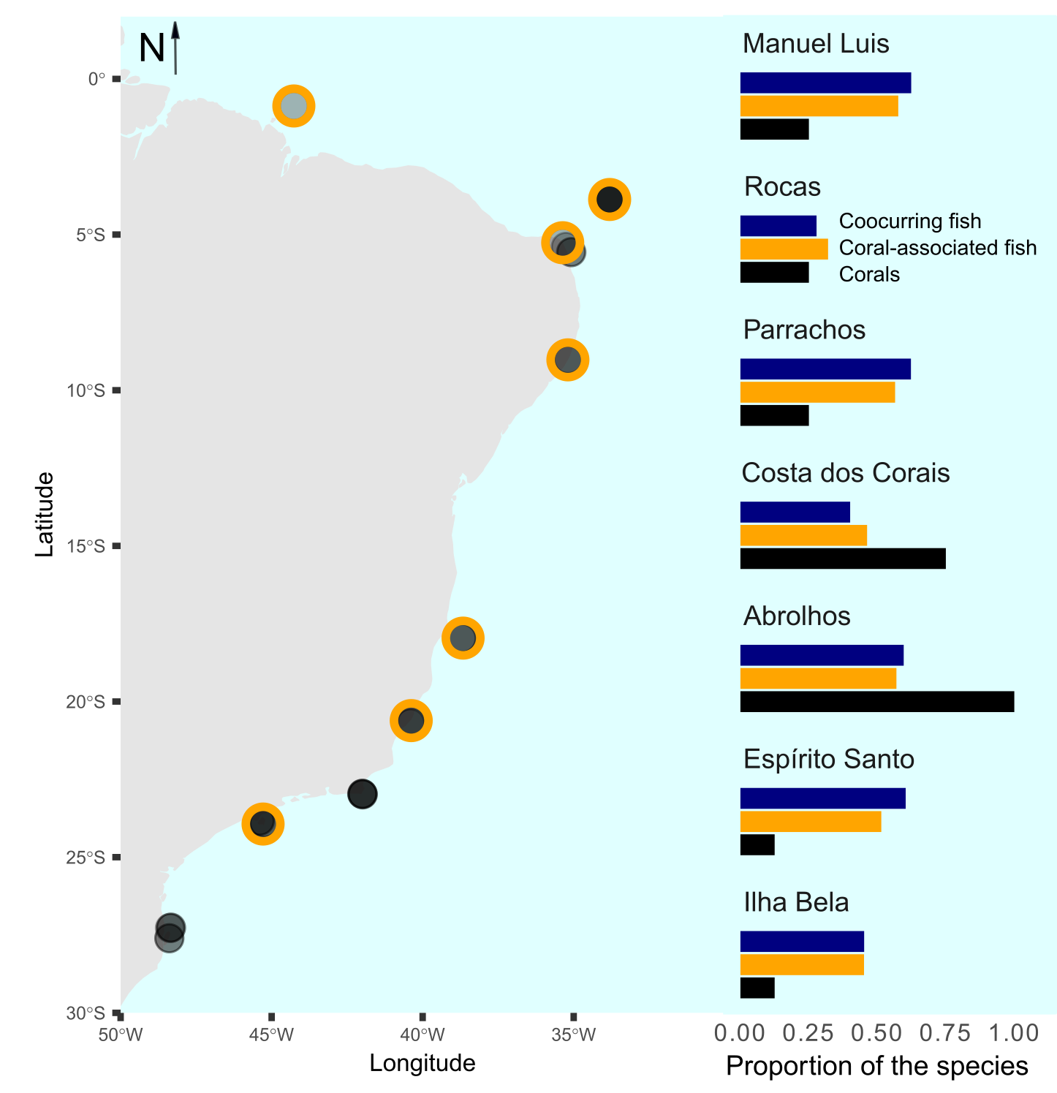

***Figure S1.1: Spatial distribution of the 36 studied sites (left) and the proportion of the total number of corals (n=8, black bars), coral-associated fish (n=42, orange bars), and co-occurring fish (n=21, blue bars) in seven selected sites (right). The selected sites are highlighted with orange strokes around points in the map. The represented localities within each site were (ordered from North to South): Manuel Luis: Ana Cristina; Rocas: Tartarugas; Parrachos: Rio do Fogo; Costa dos Corais: Gales; Abrolhos: Chapeirão; Espírito Santo: Três Ilhas; Ilhabela: Saco do Diogo.***

4- I also missed information about the scenarios of coral removed used and quantitative values regarding the impacts of those on fish assemblages, considering both the taxonomic and functional dimensions considered. For instance, from which value of coral removal would the authors observe a sharp decrease in the number of fishes and their traits? Then, in the discussion, authors could make a link with the predictions for the upcoming coral loss, how is that translated for the associated ichthyofauna? Moreover, a scenario of increasing coral cover would be useful to consider informing restoration of coral reefs (e.g., from which point would the fish species be back, and the same for their played functions).

**R30: Thank you very much for this insight. We added some projections in the results as follows (Lines 543-569):**

**“Coral removal based on degree centrality produced the lowest network robustness, considering the direct and indirect effects of coral species loss on fish taxonomic (TD) and functional diversity (FD) (Figs. 3 and 4). Despite the overlap with the confidence interval of random removals, robustness of TD considering direct and indirect effects was lower than 75% and 76% of the robustness produced by the random removals, and the robustness of FD was lower than 67% and 58% of the random removals considering the direct and indirect effects of coral species loss (Fig. 3). In contrast, the robustness of TD and FD produced by the vulnerability-based removal was generally higher than the robustness produced by random removals (Fig. 3). We hereby focus the forthcoming results on the degree centrality scenario that yielded the lower robustness to coral loss.**

**In the degree centrality scenario of coral removal, fish functional diversity showed greater robustness (R) to coral loss compared to taxonomic diversity. Despite the removal of corals and 42 fish species directly associated with them, the functional diversity of the fish assemblage remained robust in the face of the direct loss of corals (R=0.82), whereas the taxonomic diversity showed low robustness to coral loss (R=0.52). Additionally, the removal of corals and 63 fish species directly and indirectly related to corals resulted in both taxonomic and functional diversity showing limited robustness to coral loss (R=0.31 and R=0.57, respectively) (Fig. 4).**

**Along the gradient of coral species removal, we identified that the exclusion of 25% of the coral species reduced 50% of TD of coral-associated fish, but did not affect FD. The steepest decline of the FD of coral-associated fish happened after 40% of the coral species were removed (Fig. 4). The curves showed a reduction of 50% of the fish FD from 40% to 87% coral species loss (Fig. 4). Going forward in the secondary extinctions, the loss of corals caused a linear decrease in the TD and FD of co-occurring fish (Fig. 4), showing overall low network robustness to indirect effects of coral species removal.”**

**Regarding the comment about the scenario of increasing coral cover, we think it would be worthwhile if we think on a more local scale than the one used here. It could be interesting to apply your idea for a situation of site tropicalization and both coral - fish range expansion. Perhaps the links found in the original range could be maintained, or some or many links could change (beta-diversity of “habitat” interactions). This could be the scope of other studies with more refined grain data than we actually have.**

Comments along the text

L72 – it might not be clear to the overall audience the meaning of rewiring here

**R31: We had to remove text to reach the word limit of the abstract (please also see R7).**

L90 – ‘e.g.’ could be added

**R32: Changed accordingly.**

L162 - direct and indirect influence of coral loss – this is only disclosed in L282 but it is quite

important to understand what has been done and why. I recommend stating that earlier in the text, in addition to the reason why the

**R32: We changed accordingly. The section now reads (Lines 116-123):  
  
“Reef fish are connected to their habitat to different degrees, which can include the use of reef corals and macroalgae for sheltering, breeding, and foraging (Sheppard et al., 2018). Other fish can in turn associate or co-occur with coral-associated fish due to predator-prey relationships (Capitani et al., 2022), facilitation cascades, habitat engineering, and mutualistic interactions (Quimbayo et al., 2018). Reefs and the interactions they host are under threat due to global-scale climate change (Burke et al., 2023; Giglio et al., 2023), and numerous local impacts from unregulated exploitation to pollution (Bellwood et al., 2004; Giglio et al., 2023).”**

L188 - 36 sites distributed throughout the Brazilian Province – sites are not contiguous to each other. If one of the sampling sites that is small but it is nearby a large coral patch, it might be receiving species from the nearby patch, while another site that is more isolated should not. How was isolation accounted for in this study/what are the limitations and likely bias in the results underlying this aspect? It is not clear whether the probability of occupancy used has this aspect into account

**R33: We present again the answer given in R29 that fits here.**

**We appreciate the reviewer’s insight about this topic. The main intent of the benthic sampling plan was to characterize different reef sites across a continental scale (Aued et al. 2018, 10.1371/journal.pone.0198452). Although spatial data on the exact size or isolation of sampled reefs were not estimated, all sampled reefs are considered large and well-connected reef environments. No isolated and small patch reef was sampled. Thus, we believe that each sample for each site has the same chance to capture the full spectrum of cooccurrence and network provided by the local species pool and the influence of benthic characteristics.**

**To address this comment, we have incorporated a map of the study area in the Online Supporting Information to provide a visual representation of the surveyed locations (shown with the caption below). Additionally, we have added a short sentence on this matter in lines 235-242.**

**Sentences about coral isolation:**

**“One relevant aspect not considered in this model is the spatial configuration of coral or turf patches and their effects on fish occupancy. Although spatial data on the exact size or isolation of sampled reefs were not estimated, all sampled reefs are considered large and well-connected reef environments. Accordingly, we assumed that each sample for each site had the same chance to capture the full spectrum of cooccurrence and network provided by the local species pool and the influence of benthic characteristics.”**

L220 – the link between partite A and B is the probability of a coral reef associated species to be present in the coral, yet the link between partite B and C seems to be the probability of species cooccurrence. In multilayer approach, the links should remain the same… I am afraid the authors have a tripartite network but not a multilayer network (see Pilosof et al. 2017) (L263 – ‘To simulate extinctions, we worked in parallel in the two bipartite networks.’ – the authors seem to be working not at the multilayer level..)

**R34: We agree and adjusted accordingly throughout the text.**

L225- ‘We tested whether species from the partite C belonged to higher trophic levels and had larger body sizes than species in the partite B using ANOVA.’ – what would then be the underlying mechanism for this? there is nothing said about this in the introduction…

**R35: Thank you for this comment. We now mentioned in the introduction how the two networks could be connected. We used the ANOVA to detect whether trophic level was higher among co-occurring fish than coral-associated fish -- and it was indeed the case (see also R28).**

L262 – ‘coral with the largest number of associated fishes were the first to be eliminated’: why? Are those more likely to undergo removal? And why not trying different scenarios?

**R36: Although the corals with the highest degree are not those most likely to be lost, they seem to provide the most complex habitat for fish. This scenario aligns with other research showing that species with high degree centrality are key to network stability (Bastazini et al. 2019 and references therein, DOI:** [**10.1017/S0376892918000334**](http://dx.doi.org/10.1017/S0376892918000334)**). Please see the R1 that also clarifies this topic.**

L342 – ‘coral loss has the potential to decrease the trait area of fish assemblages at the province scale by 69%’ – to which amount of coral loss do the authors refer to? Also, avoid using terms such as ‘our findings suggest’ in the results section (it is rather appropriate to use it in the discussion).

**R36: We adjusted to (lines 562-569):**

**“Along the gradient of coral species removal, we identified that the exclusion of 25% of the coral species reduced 50% of TD of coral-associated fish, but did not affect FD. The steepest decline of the FD of coral-associated fish happened after 40% of the coral species were removed (Fig. 4). The curves showed a reduction of 50% of the fish FD from 40% to 87% coral species loss (Fig. 4). Going forward in the secondary extinctions, the loss of corals caused a linear decrease in the TD and FD of co-occurring fish (Fig. 4), showing overall low network robustness to indirect effects of coral species removal.”**

L351 – this should be moved to the discussion

**R37: Changed accordingly.**

Figure 1 – it is not clear to which species in partite B are the species from partite C linking to

**R38: We tried to improve the figure network to meet your request (now it is Figure 2, because we included the map of the studied area). We differentiate fish groups per color, and set in bold the coral-associated fish. Indeed, it was hard to represent all this in the same figure. In addition, note that we edited the figure to show the two partities and the node sets (following Timoteo et al. 2022, DOI:** [**10.1111/1365-2435.14206**](https://doi.org/10.1111/1365-2435.14206)**). Hope you’re satisfied with this new version of the figure.**

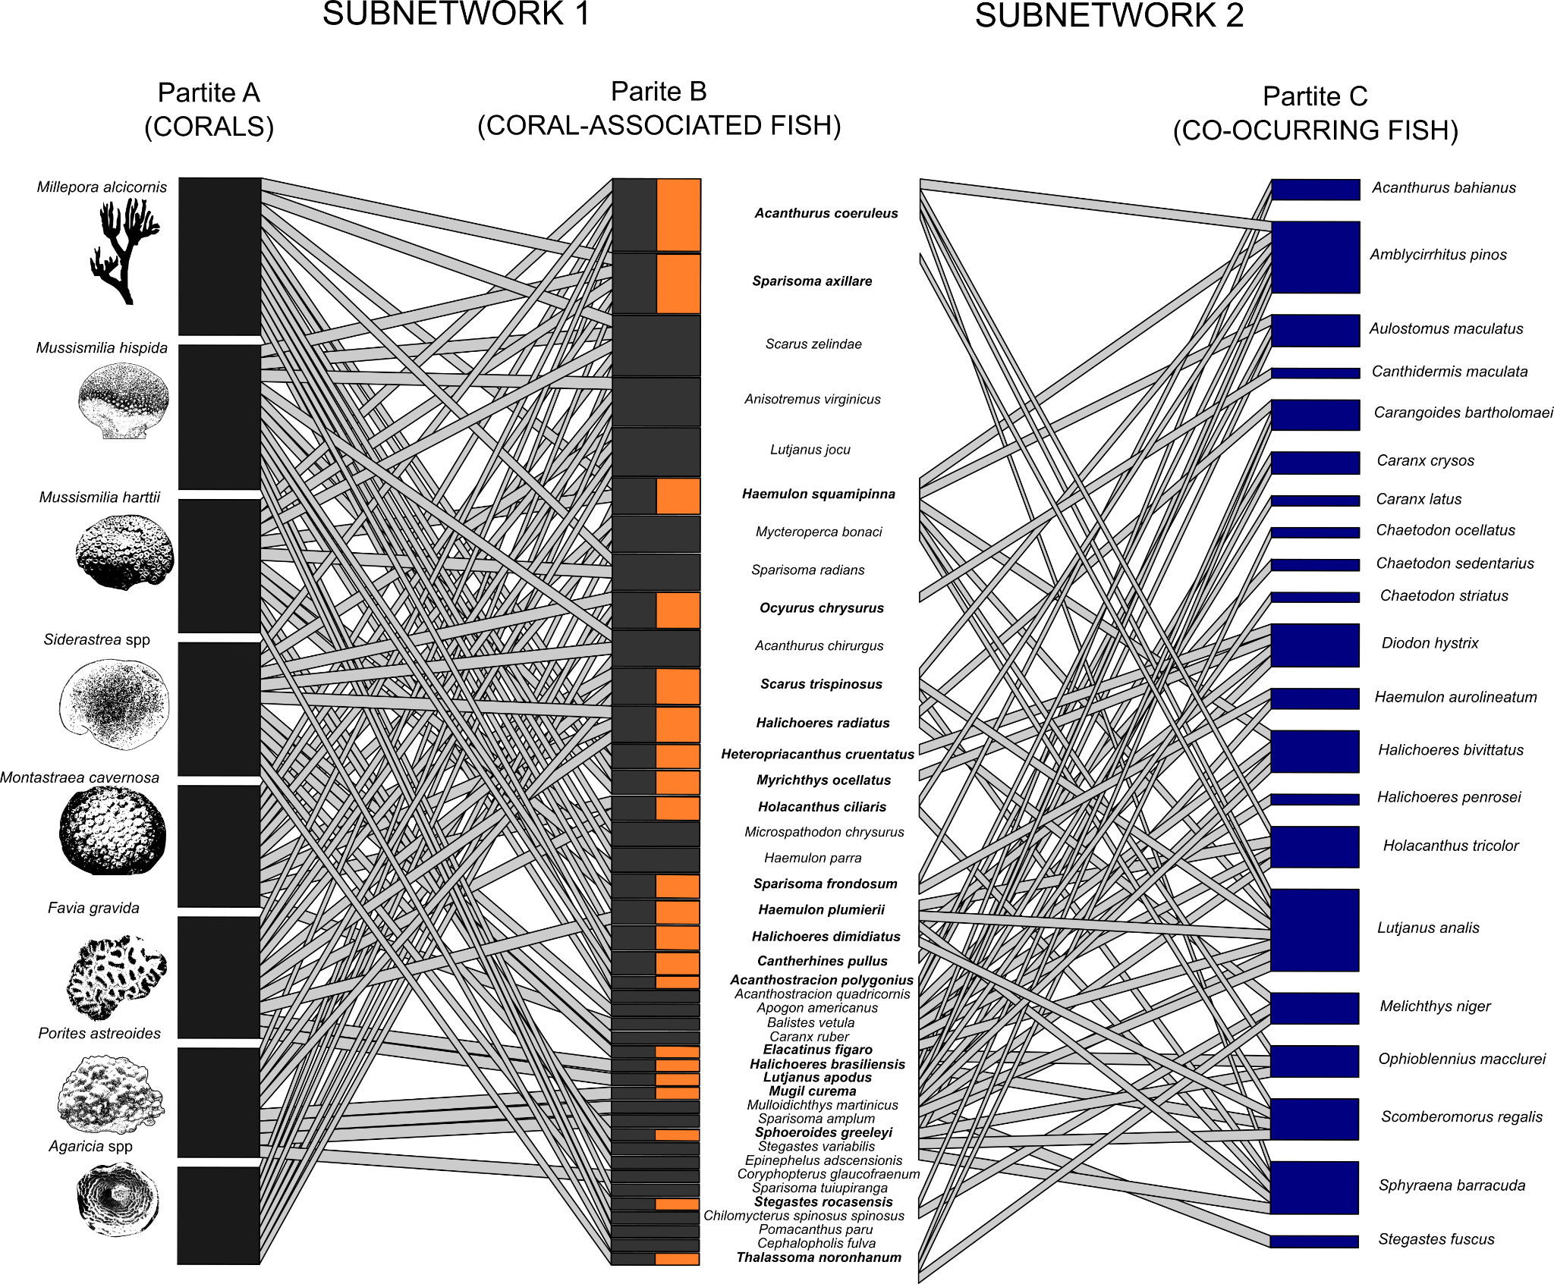

***Fig. 2 - Tripartite network showing the two subnetworks and their partites. In this network, the habitat is characterized by the cover of scleractinian corals and hydrocorals (left part). The network is organized according to the decreasing number of fish species associated with different corals. The width of the links in the left network depicts the predicted site occupancy probability by fish species () as a function of coral cover (while maintaining turf algae cover constant), and in the right part the width of the links depicts the correlation between the site occupancy probability of coral associated fish and co-occurring fish. The height of black bars in Partite A depict the number of fishes associated with each coral species. The height of gray bars in Partite B depict the number of corals that each fish was associated with, and the height of bars in Partite C show the number of coral-associated fish that each co-occurring fish was connected (only pairwise correlations higher than ρ ≥ 0.8 were projected in the figure and used in data analysis). The orange bars and bold scientific names in the partite B highlight coral-associated fish that establish relationships with co-occurring fish.***

Figure 2 – the text above the figure would be better presented in the legend, same for figure 3

**R38: Changed accordingly.**

Figure 3 – I was wondering whether this figure could be complemented by a panel illustrating what are the overall effects by computing both direct + indirect effects, thereby showing what are the effects that actually take place.

**R39: Changed accordingly. We added a small panel between the two plots of side A depicting the percentage of the Provincial trait space area occupied by each group. We also tried to match the colors across all the manuscript figures to avoid confusion. The figure now looks like:**

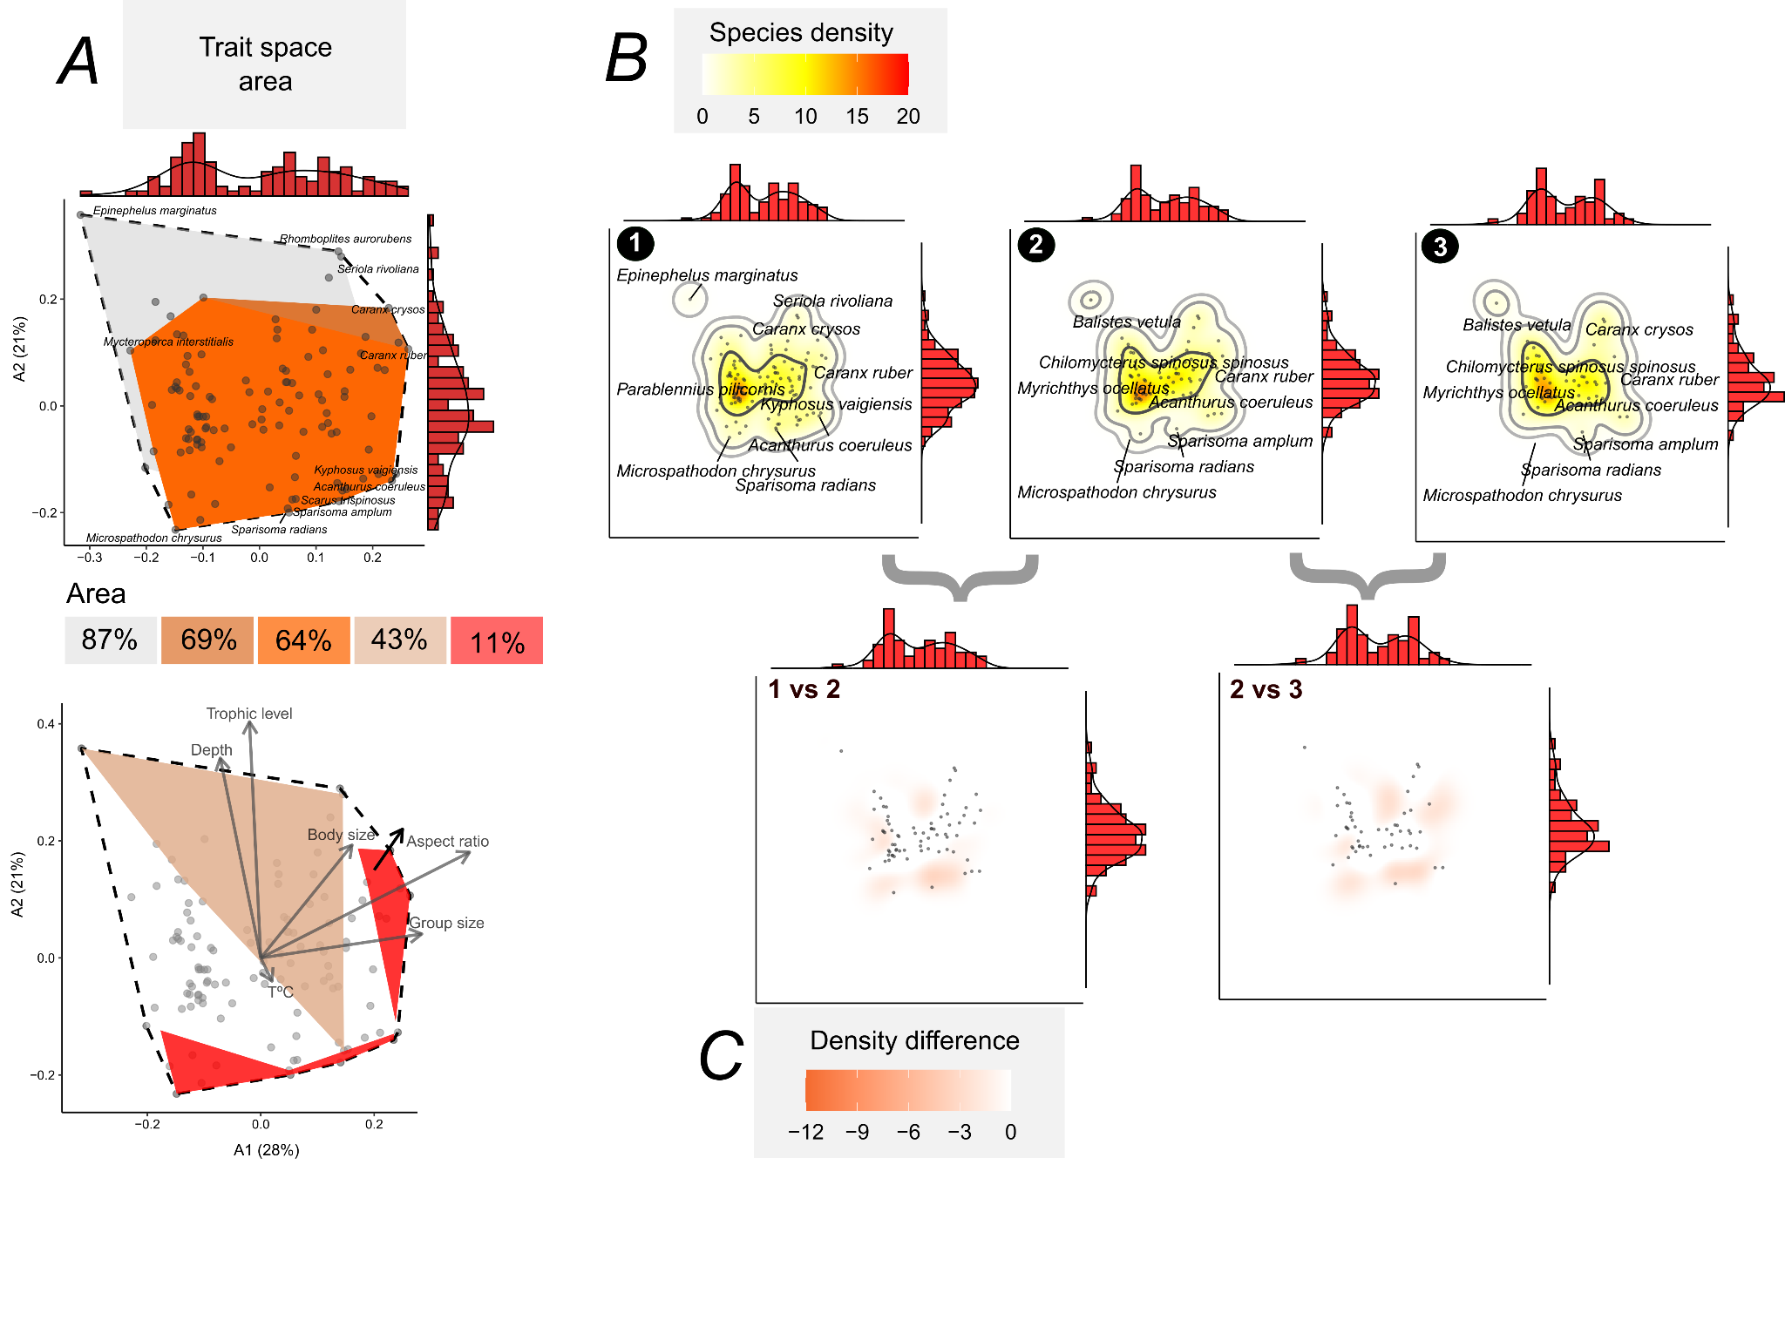

***Fig. 5 - Trait space occupancy by reef fish in the Brazilian Province, based on these results of the degree centrality scenario. At the top of A, we show the trait spaces of the Brazilian Province fish (n=113 species, white polygon with black dashed line), coral-associated fish (n=42, orange, trait space area: 64%), coral-associated + co-occurring fish (n=63 species, dark orange polygon, area: 69%), remaining species (n=50, inner light gray polygon, area: 87%). At the bottom of A, we show the correlation of each trait with the two first ordination axes, and the polygons of threatened species (brown polygon, area: 43%) and the area vulnerable to cascading extinctions (red, area: 11%). In B, we show trait space occupancy within the Provincial trait space (1), and the trait space occupancy after simulating the direct (2) and indirect effects of removing corals according to the degree centrality scenario (3). The density (trait space occupancy) was produced by a kernel density estimation algorithm, with contours depicting 50%, 95%, and 99% kernel density bands. In C, we show the difference in trait space occupancy after simulating the direct (1 vs 2) and indirect effects of losing coral species (2 vs 3). The marginal histograms (with density shown) of all plots depict the concentration of points (species) in the trait spaces. The trait space was produced by summarizing trait data with a Principal Coordinate Analysis (PCoA), and the variation explained by these axes are presented in the first plot (A).***

L415 – I would rather expect to see here a re-call to what was the main finding of this study, instead of a repetition of the information regarding what has been done

**R40: We edited this whole section, which now reads (Lines 649-669):**

**“Coextinctions are difficult to observe in nature as they are hard to detect or unfold over long time scales (Estes et al. 2011). Using simulated cascade extinctions in a tripartite species-habitat network, we showed that cascading loss of reef fish species and functions can occur as a response to coral species loss in Southwestern Atlantic reefs. There was a limited robustness of the network and ecological trait space to the direct and indirect influence of the removal of corals with high degree centrality. By evaluating network robustness across the gradient of coral species loss, our analyses of co-extinctions can represent a more realistic and applied scenario in terms of conservation than our previous results (Luza et al., 2022) based on a more conservative scenario of direct extinction of coral-associated fishes. Notably, fish TD and FD was more robust to the removal of the corals most vulnerable to bleaching, showing a weak relationship between coral bleaching vulnerability and fish assemblage vulnerability. The removal of corals with more associated fish (highest degree centrality*, Millepora alcicornis, Mussismilia hispida*) caused the largest direct and indirect impacts on the network's robustness. It was already shown for a seed dispersal network that species with a high degree centrality confer network robustness and stability (Bastazini et al., 2019). Such results are particularly useful for informing management and conservation actions, informing the key corals and fish to target conservation considering the major coral loss scenarios projected over the next 76 years (Bleuel et al., 2021; Freeman et al., 2013; Hoegh-Guldberg et al., 2007).”**

L435 – ‘initially’ in relation to what? This study is not considering the temporal dimension, a more appropriate wording might be required here

**R41: We were referring to the direct effect of coral loss. We removed “initially” from the sentence**

L251 – that was observed when considering the taxonomic dimension, but not the functional one, so better to be specific

**R42: We could not address this suggestion because we did not find the context in the mentioned line. The Line 251 in the original manuscript refers to one of the algorithm steps, Line 521 was about rewiring, and line 512 was about the study of Blanchet et al. (2020).**

L519 – ‘the goal here was to evaluate robustness and present a new algorithm for functional robustness evaluation’ – yet nothing is said in the introduction about the goal regarding the new algorithm

**R43: We added a small sentence in the introduction to say clarify this aspect (lines 180-186):**

**“Here, beyond using a tripartite network to estimate direct and indirect effects of habitat patch loss to taxonomic diversity, we take a step forward in coextinction analysis and design an algorithm that evaluates network functional robustness. We applied this approach for corals and fish of Southwestern Atlantic reefs, and considered three scenarios of coral (habitat) species loss: degree centrality, vulnerability to bleaching and post-bleaching mortality, and random removal.”**